**CONTROL OF ROBOTIC CONVOYS USING MASTER/SLAVE CONCEPT**

|  |
| --- |
| **KONTROL VE OTOMASYON MÜHENDİSLİĞİ TASARIMI I**  **FİNAL RAPORU**  **Ali İhsan ÇOMAKLI**  **(040170423)** |
| **Danışmanı: Prof. Dr. Hakan TEMELTAŞ** |
|  |
| **KONTROL VE OTOMASYON MÜHENDİSLİĞİ BÖLÜMÜ** |

1. **INTRODUCTION / LITERATURE RESEARCH**

The control of a robotic convoy is a multi-part problem. The vehicles in the mentioned convoy can vary almost endlessly. For this study, land vehicles are selected as the only vehicles in the convoy and each vehicle have similar behaviours. With such approach, there is a need for only one vehicle model. A single car vehicle model is obtained by analysing [1] and [2]. To control the convoy with master/slave approach, [3] and [4] are investigated and will be studied further. Control of a single car is modelled and further studies are discussed in following sections. The timeline below is to be followed throughout the 2021-2022 academic year.

|  |  |  |  |  |  |  |  |  |  |  |  |  |  |  |  |  |  |  |  |  |  |  |  |  |  |  |  |  |  |
| --- | --- | --- | --- | --- | --- | --- | --- | --- | --- | --- | --- | --- | --- | --- | --- | --- | --- | --- | --- | --- | --- | --- | --- | --- | --- | --- | --- | --- | --- |
| **Work Packages** | **Weeks** | | | | | | | | | | | | | | | | | | | | | | | | | | | | |
| **1** | **2** | **3** | **4** | **5** | **6** | **7** | **8** | **9** | **10** | **11** | **12** | **13** | **14** | **15** | **16** | **17** | **18** | **19** | **20** | **21** | **22** | **23** | **24** | **25** | **26** | **27** | **28** |
| Research | X | X | X | X | X | X | X |  |  |  |  |  |  |  |  |  | x | x | x | x | x |  |  |  |  |  |  |  |
| Single Lane Control |  |  |  |  |  |  |  | x | x | x | x | x | x | x |  |  |  |  |  |  |  |  |  |  |  |  |  |  |
| Single Car Modelling |  |  |  |  |  |  |  | x | x | x | x |  |  |  |  |  |  |  |  |  |  |  |  |  |  |  |  |  |
| Speed Control |  |  |  |  |  |  |  |  |  |  | x | x | x | x |  |  |  |  |  |  |  |  |  |  |  |  |  |  |
| Control Signal Limitations |  |  |  |  |  |  |  |  |  |  |  |  |  |  | x |  |  |  |  |  |  |  |  |  |  |  |  |  |
| Multiple Car (Convoy) Model |  |  |  |  |  |  |  |  |  |  |  |  |  |  | x | x | x |  |  |  |  |  |  |  |  |  |  |  |
| Master-Slave Communication |  |  |  |  |  |  |  |  |  |  |  |  |  |  |  | x | x |  |  |  |  |  |  |  |  |  |  |  |
| Multiple Lane Control |  |  |  |  |  |  |  |  |  |  |  |  |  |  |  |  |  | x | x | x | x | x | x | x | x | x | x | x |
| Single Car Modelling |  |  |  |  |  |  |  |  |  |  |  |  |  |  |  |  |  | x | x |  |  |  |  |  |  |  |  |  |
| Car Control in Multiple Lane |  |  |  |  |  |  |  |  |  |  |  |  |  |  |  |  |  |  |  | x | x | x | x |  |  |  |  |  |
| Multiple Lane Convoy Control |  |  |  |  |  |  |  |  |  |  |  |  |  |  |  |  |  |  |  |  |  |  |  | x | x | x | x | x |

Table 1: Timeline

In this study, design of a controller is proposed for a multiple car model on a single lane path. In this approach, the vehicles only move in one dimension, leading to the suggestion that arriving to a destination with the awareness of objects located in only front and back is enough. To model such convoy, modelling and controlling of an exemplary single car is investigated firstly. Using necessary feedback units, the car is to be controlled. As with any control system, it must be taken into account that the control signal must be applicable. After that, convoy movement patterns are designed considering the integrity of each vehicle. To apply the convoy patterns, each vehicle is controlled by one master vehicle. Master vehicle receives feedback signals from each vehicle and sends control signals to each vehicle individually. The communication methods and modelling of a convoy in a multiple lane scenario (in two dimension) can be improved upon this study.

The paper is organized as follows. In Section II, a brief introduction to convoy control is provided. In Section III, the controller design method is proposed in a single lane scenario for single car and multiple car models. Simulation results of the proposed method are presented and compared. Conclusion and discussion are in Section IV.

1. **THE PROBLEM DESCRIPTION**

In this section, the problem can be divided in two parts. In the first part, the control of a single vehicle is aimed to be designed on a single-lane scenario. In second part, multiple vehicle control in same scenario is discussed. For each part, modelling of a single car is examined, then the convoy patterns are designed assuming that every vehicle have similar properties.

For autonomous cruise control, each of the dynamic properties, i.e. acceleration, velocity and position are all must be observed and controlled. It can be suggested that a vehicle works in two modes, acceleration and deceleration, or more simply, gas pedal and brake pedal. Considering that the drag caused by air, tires, and inner characteristics resistances is constantly slowing down the vehicle, the gas pedal is to be used to an extent to achieve constant speed, that means the vehicle must be working on the acceleration mode. The drag also causes that deceleration can still occur while pressing down the gas pedal very lightly (for very small inputs in acceleration mode). While this deceleration can still be observed in the acceleration mode, it is not going to be used in deceleration mode, meaning that gas pedal is not going to be used in the deceleration mode. Even though the drag changes direction when the vehicle is reversing (v<0), the mode shift logic above does not change since while reversing the vehicle moves at relatively low speed. In addition, reversing movement is not highly used in this scenario.

For acceleration mode, the engine produces power for the vehicle to achieve an acceleration needed for the desired velocity. A simple representation of obtaining the vehicle's position from the force exerted by the engine is shown below.

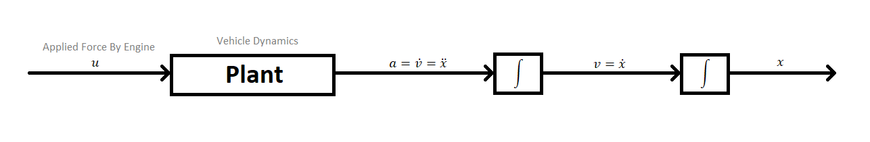

Figure 1: Simple Representation of the Plant

It must be noted that control signal “u” must be saturated and also as smooth as possible for the safety of the inner dynamics of the vehicle. In addition, the velocity of the vehicle must be limited for traffic rules and regulations.

For a better approach, the free body diagram below can be used.

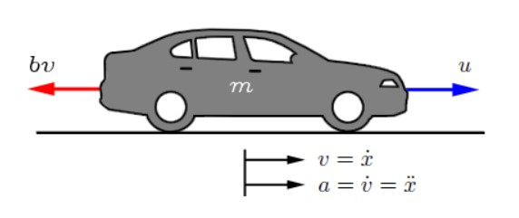

Figure 2: A Different Approach to the Plant

“b” is the drag coefficient that is assumed to be linearly dependant to the velocity of the vehicle.

By applying Newton’s 2nd Law,

$$F_{net}=m*a$$

$$u-b*v=m*\dot{v}$$

Using a state space model, the output of the vehicle is equal to “v”, since the velocity of the vehicle is to be controlled.

$$\dot{x}(state)=\dot{v}=\left[-\frac{b}{m}\right]v+\left[\frac{1}{m}\right]u$$

$$y=\left[1\right]v$$

So the transfer function of the vehicle

$$P\left(s\right)=\frac{V\left(s\right)}{U\left(s\right)}=\frac{1}{ms+b} \left[\frac{s}{kg}\right]$$

1. **CONTROLLER DESIGN**

The representation in Figure 1 can be further extended as below.

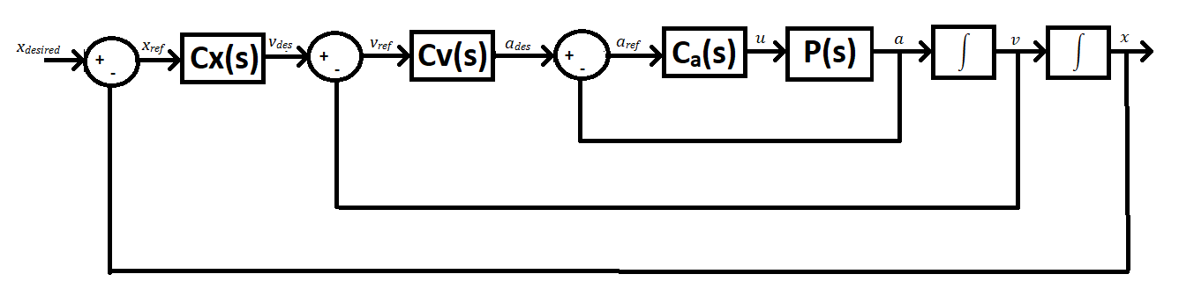

Figure 3: Extended Representation

Before designing the controllers in Figure 3, a decision making structure is to be proposed for limiting the velocity in different situations. This structure can be observed in the pseudocode below.

%maximum velocity of a vehicle in traffic is taken as 50 km/h

%50 km/h = 13.8 m/s, taken as 13.5 m/s for rounding purposes

input(front_sensor) %in the range of 0-135, 135 meaning that an object is as close as 1 meter to the vehicle, 0 means no objects are detected in 21 meters

input(rear_sensor) %in the range of 0-135, same logic

for acceleration_mode==1

v_max = (135-front_sensor)/10 [m/s]

if v_max==13.5 or v_des>13.5

v_des=13.5

else if v_max<v_des

v_des=v_max

else

v_des=x_ref*Cx(s)

end

end

for decceleration_mode==1

v_min = -(135-rear_sensor)/30 %reversing is assumed 3 times slow

if v_min==-4.5 or v_des<=-4.5

v_des=-4.5

else if v_min>v_des

v_des=v_min

else

v_des=x_ref*Cx(s)

end

end

This structure is to be used in the position controller $C_{x}(s)$.

Further design of controllers is going to be improved upon this study in 2021-2022 Spring Semester.

For multiple vehicle control with master/slave robot concept, or convoy control using master/slave concept, the first approach to the problem is that controlling each vehicle separately by one master vehicle is to be designed. Convoy movement patterns such as lining up can be applied later on in multiple-lane scenario. To control each vehicle separately, master vehicle must get and process the kinematic magnitudes, along with front and rear sensors of each vehicle separately. The same control loop and the same controller design is to be used in the control of each vehicle. Since it is a single-lane scenario, the order of the vehicles cannot change, thus convoy movement patterns before-mentioned are not used in this scenario. The data communication methods for master/slave concept is going to be applied in next semester as they are only needed in multiple-lane scenario.

1. **CONCLUSION**

Single vehicle is modelled and necessary feedbacks and control loops are defined. A simple approach of limiting some kinematic magnitudes for official regulations is proposed. Control signals are to be observed in following semester to achieve smoothness in movement, along with multiple-lane scenario and communication methods. Although the content of this work is not very intense, it serves the purpose of determining the guidelines that must be followed in order to complete the paper.

**REFERANCES**

[1] Şentürk S., *The Middle East Technical University*. “Experimental Determination of Transfer Functions for a Car”, 2004

[2] Yang and others. “Truck acceleration behaviour study and acceleration lane length recommendations for metered on-ramps”, 2016. <https://doi.org/10.1016/j.ijtst.2016.09.006>

[3] Suescun, Cardei. “Unmanned Aerial Vehicle Networking Protocols”, 2016.

[4] Belkhouche, *IEEE*. “Modeling and Controlling a Robotic Convoy Using Guidance Laws Strategies”, 2005. DOI: 10.1109/TSMCB.2005.846646

[5] Celtek, Durdu, Kurnaz. *Design and Simulation of the Hierarchical Tree Topology Based Wireless Drone Networks*, 2018. DOI: 10.1109/IDAP.2018.8620755

[6] Liu, Özgüner. “Predictive Control of a Vehicle Convoy Considering Lane Change Behavior of the Preceding Vehicle”, 2021.